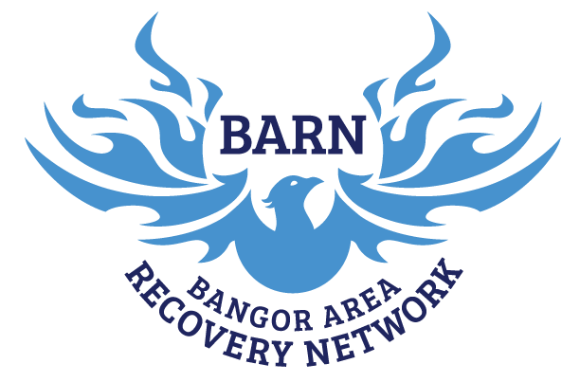

Rental Request

Please submit by the 15th of the month before your event or meeting.
*This ensures we have enough time to notify other meetings and events so they can prepare to relocate and make room for new requests*

POLICY:
The Bangor Area Recovery Network, Inc. policy is to provide a safe environment for those in recovery. While the mission is primarily related to substance abuse addiction recovery, BARN also is open to supporting other types of addiction, such as food addiction or gambling, as well as offering support to those who are affected by another’s addiction, such as family members, children, and others who may be similarly affected by addicted or recovering individuals. In order to coordinate and schedule potential groups/meetings at the BARN’s community recovery center, all requests must be submitted to the Community Outreach Specialist for consideration and/or approval.
- The BARN reserves the right to deny, amend or terminate any rental request or agreement any time at its discretion.
- The BARN reserves all rights over rented spaces and may ask a group to temporarily move their meeting to accommodate a special event or function. Regularly scheduled groups/meetings will be given at least 30 days notice and credit for any rent paid in advance.
- Our facility is open to the public during all regular business hours. Therefore, renting the whole building does not grant the renter the right to regulate access to the facility.
- Group and event members, participants and attendees are expected to adhere to the BARN rules. When rules are not adhered to, group members are expected to, within reason, hold participants and attendees accountable to those rules. If violation of BARN rules continues, a group/meetings rental agreement may be terminated at the BARN’s discretion.
- BARN volunteers are not obligated or expected to support and set up, break down or other functions related to group activity.

PROCEDURES:
- Requests to rent space or hold meetings at the BARN’s community recovery center are to be submitted to the Community Outreach Specialist no later than the 15th of the month before the event or first meeting. Requests may be left in the BARN’s Community Outreach Specialist office in advance of the meeting or given directly to the Community Outreach Specialist. If anyone feels as though an explanation of the request is necessary please contact the Community Outreach Specialist.
- Requests will be reviewed by the Community Outreach Specialist at the earliest possible time, and review of the application will consists of a search for the two criteria below:
  - Appropriateness of request and its compatibility with the BARN’s mission; and
  - Possible dates, times and room location for the meeting in order to ensure it does not conflict with existing scheduled events/meetings.
- All requests will be submitted using the BARN Rental Request Form (see attached).
- Upon review of the application, the Community Outreach Specialist will
  - Approve the request as submitted.
    - If approved, the Community Outreach Specialist will confirm the dates, time, and location for the meeting with the applicant.
    - Once confirmed by the applicant, the meeting will be added to the schedule.
  - Require further information from the applicant before rendering a decision.
    - Further information may slow the approval process. It may be asked for in writing, by phone, or addressed in person to the Community Outreach Specialist.
    - Once information is obtained, a decision will be rendered as quickly as possible.
  - Reject the application
    - If rejected, the application will be told why the request was denied.
    - Unless otherwise informed, the applicant may amend the request to eliminate any objection and re-submit for consideration for approval.
    - If the applicant disagrees with the decision to reject the request, they may ask the Community Outreach Specialist to refer the request to the Executive Committee of the Board of Directors for review.
  - Refer the application to the Board for final decision.
    - If unable or unwilling to render a decision, the Community Outreach Specialist at their discretion, may refer a request to the Board of Directors for a decision.
    - The Board will notify the applicant of its decision as soon as possible.

Contact Person:
This person takes responsibility for the space and serves as liaison between the BARN and renters.

Name: ______________________________ Phone Number: _________________________
Email Address: _____________________________________________________________
Date, Time, Duration:
First choice day: ___________ Second choice day: ___________ Third choice day: ___________
First choice time: __________ Second choice time: __________ Third choice time: __________
❐ Weekly ❐ Bi-Weekly ❐ One Time Event/Meeting Duration of meeting: _____________
Use of Technology:
Will this meeting be hybrid? ❐ Yes ❐No
Do you need to use the BARN zoom account? ❐ Yes ❐No
Meeting/Event Type:
If a 12 Step Program, which do you represent? (AA, NA, OA, GA, Al-Anon, Narc-Anon, Alateen..other)

❐ AA ❐ NA ❐ OA ❐ GA ❐ Al-Anon ❐ Nar-Anon ❐ Alateen ❐ Other: ___________

________________________________________________________________________

If an event, please briefly describe: ________________________________________________
________________________________________________________________________
________________________________________________________________________
Name/Title of Group or Event: __________________________________________________
Would you like to become a volunteer at the BARN? ❐ Yes ❐No
Would you like the event posted to the BARN Facebook Page? ❐ Yes ❐No
(Note: BARN reserves the right to deny Facebook requests. We will not promote any 12 step groups)

The BARN will respond to your request within 5 days.
Please return all Rental Request Applications to our Community Outreach Specialist, Maddy Valle.
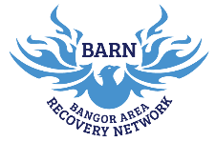

Space Reservation Options (Please circle one):

Large Open Community Area (zoom capability)
- $25.00/hr.
- $100.00 for a 5 hour block
- $10.00/hr for 12 step/Recovery based Peer support

Board Room (zoom capability)-
- $10.00/hr
Kitchen
- $10.00/hr
Entire Building
*Please speak with the Community Outreach Specialist about pricing.

Coffee is available for meetings for $4.00 a pot

Would you like coffee to be included for $4.00 a pot?
❐ Yes ❐No

Applicant Signature: ___________________________________
Date: _______________
Community Outreach Specialist Signature: ___________________
Date: _______________
Approved Start Date: ____________ Total Monthly Cost: ________
*The BARN reserves the right to require full payment in advance for large events or at its discretion based on the nature and size of the event*

